**User Manual of Quizjet Authoring**

The main objective of this authoring tool is to help instructor create questions which can be used in quizjet system. It includes three major components: Topic, Question and Concept.

**1.** **Topics**

In this authoring tool, you can create a topic in java domain.

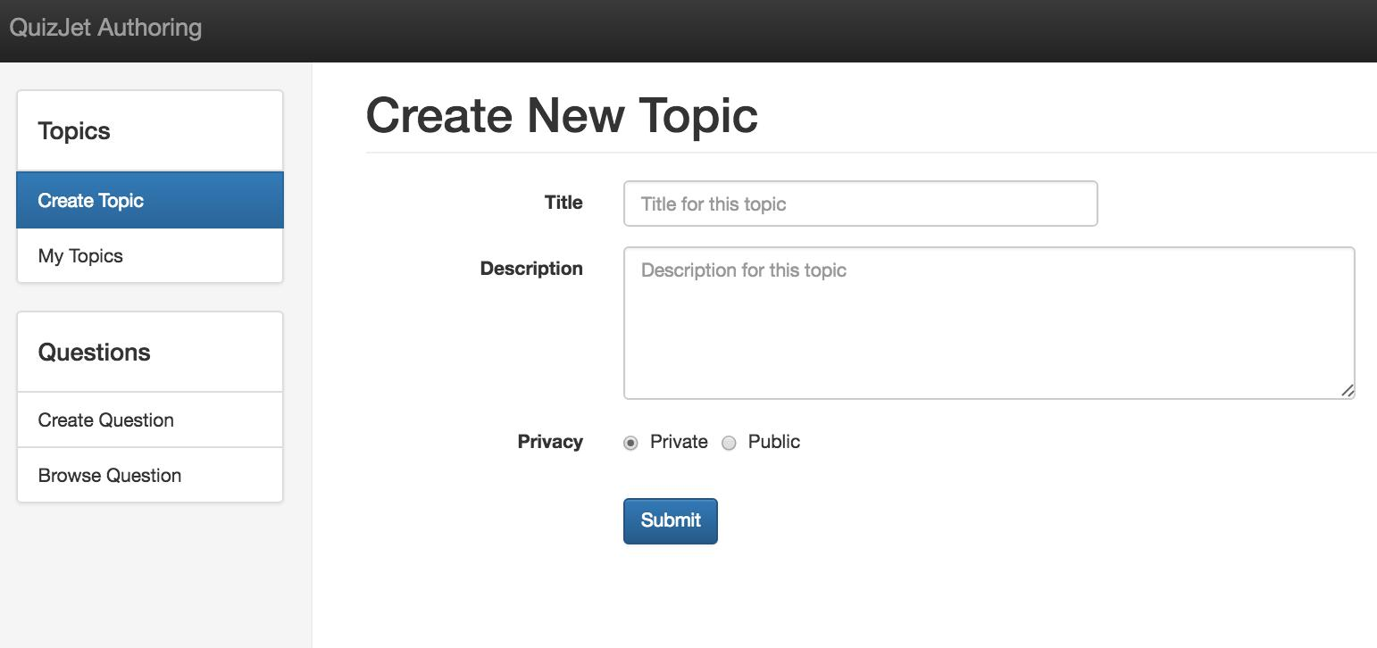

You can also browse all your topics and edit your topics.

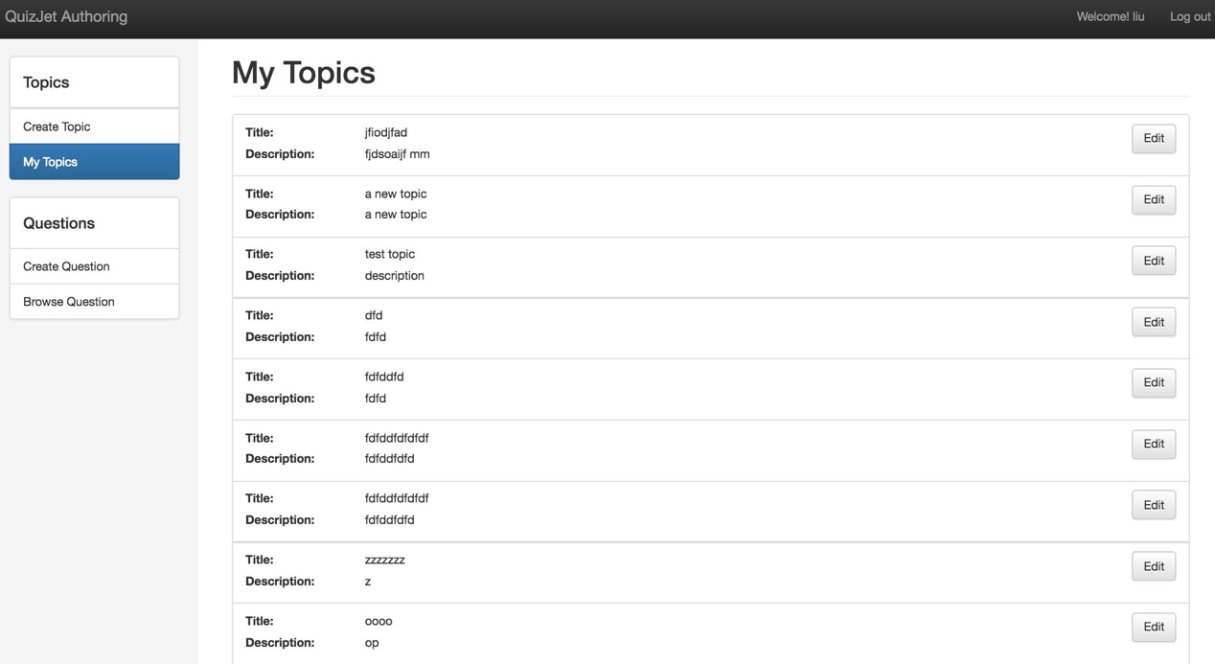

**2.** **Questions**

There are two ways to create a question. The first way is to create a question from scratch. The second way is to clone a question from an existing question in the system.

In the first method, you can create a question which belongs to a specific topic.

This topic could be your own topic or the public topic created by the other user.

Pay attention to the code template.

1. We provide a Tester class, you should put your test method in this class.
2. Don’t change the name “Tester”
3. Your code should be compilable, otherwise it will be rejected by the system.

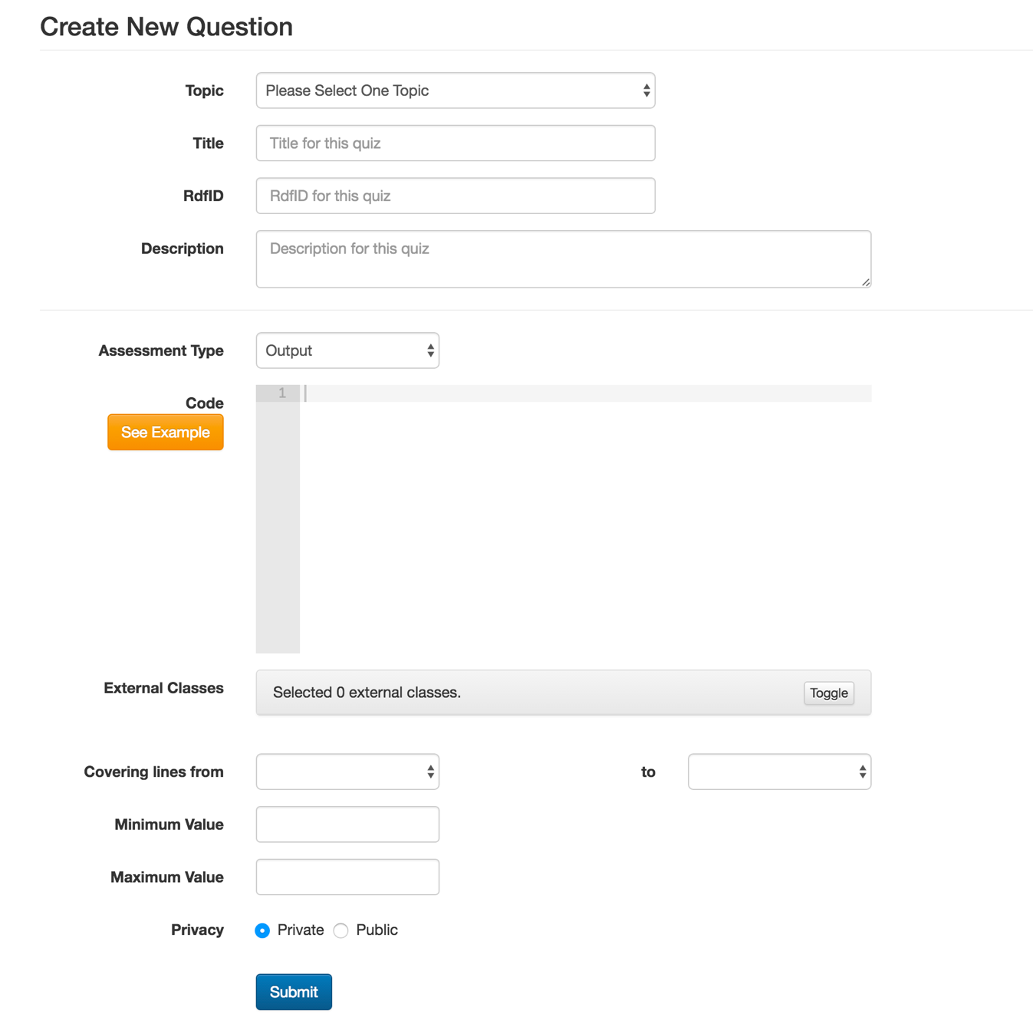

If your code is dependent on the other class files, you can also add these files as external classes by clicking the “Toggle” button. All the external files will be listed. You can upload you own files or choose existing files. Please avoid name conflict.

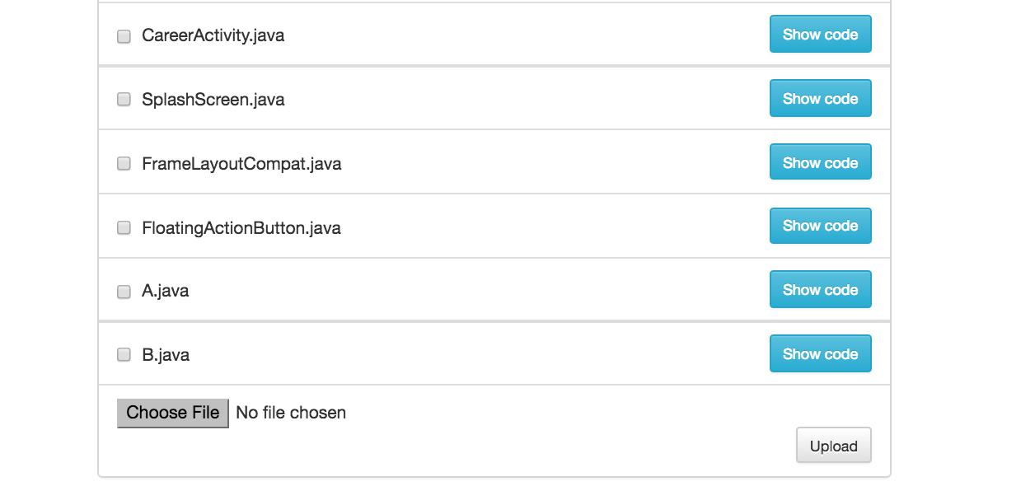

Important: If you try to create a new question whose Assessment Type is Final Value, please type another one line before the end of main method. Just as shown below.

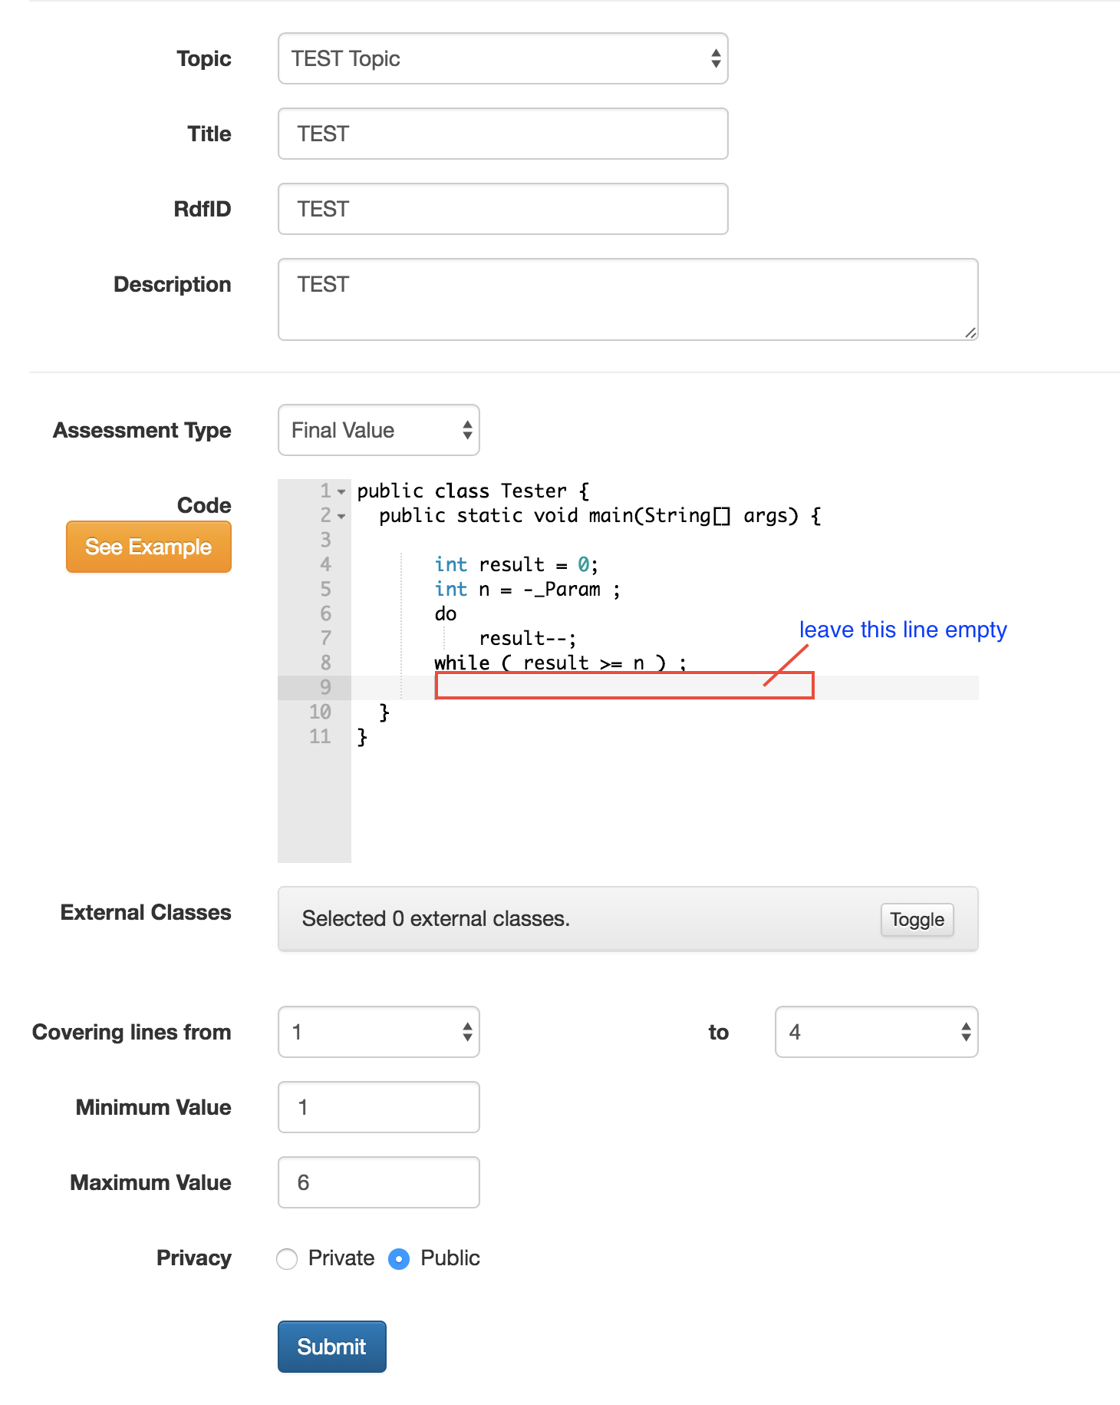

As we mentioned before, you can create a question by cloning. First you need to go to the “browse question” tab. You can browse questions by topics and filter them by title , description or the author name. You can clone your own question and the public questions from the other users. You can only edit question and concepts of your own questions.

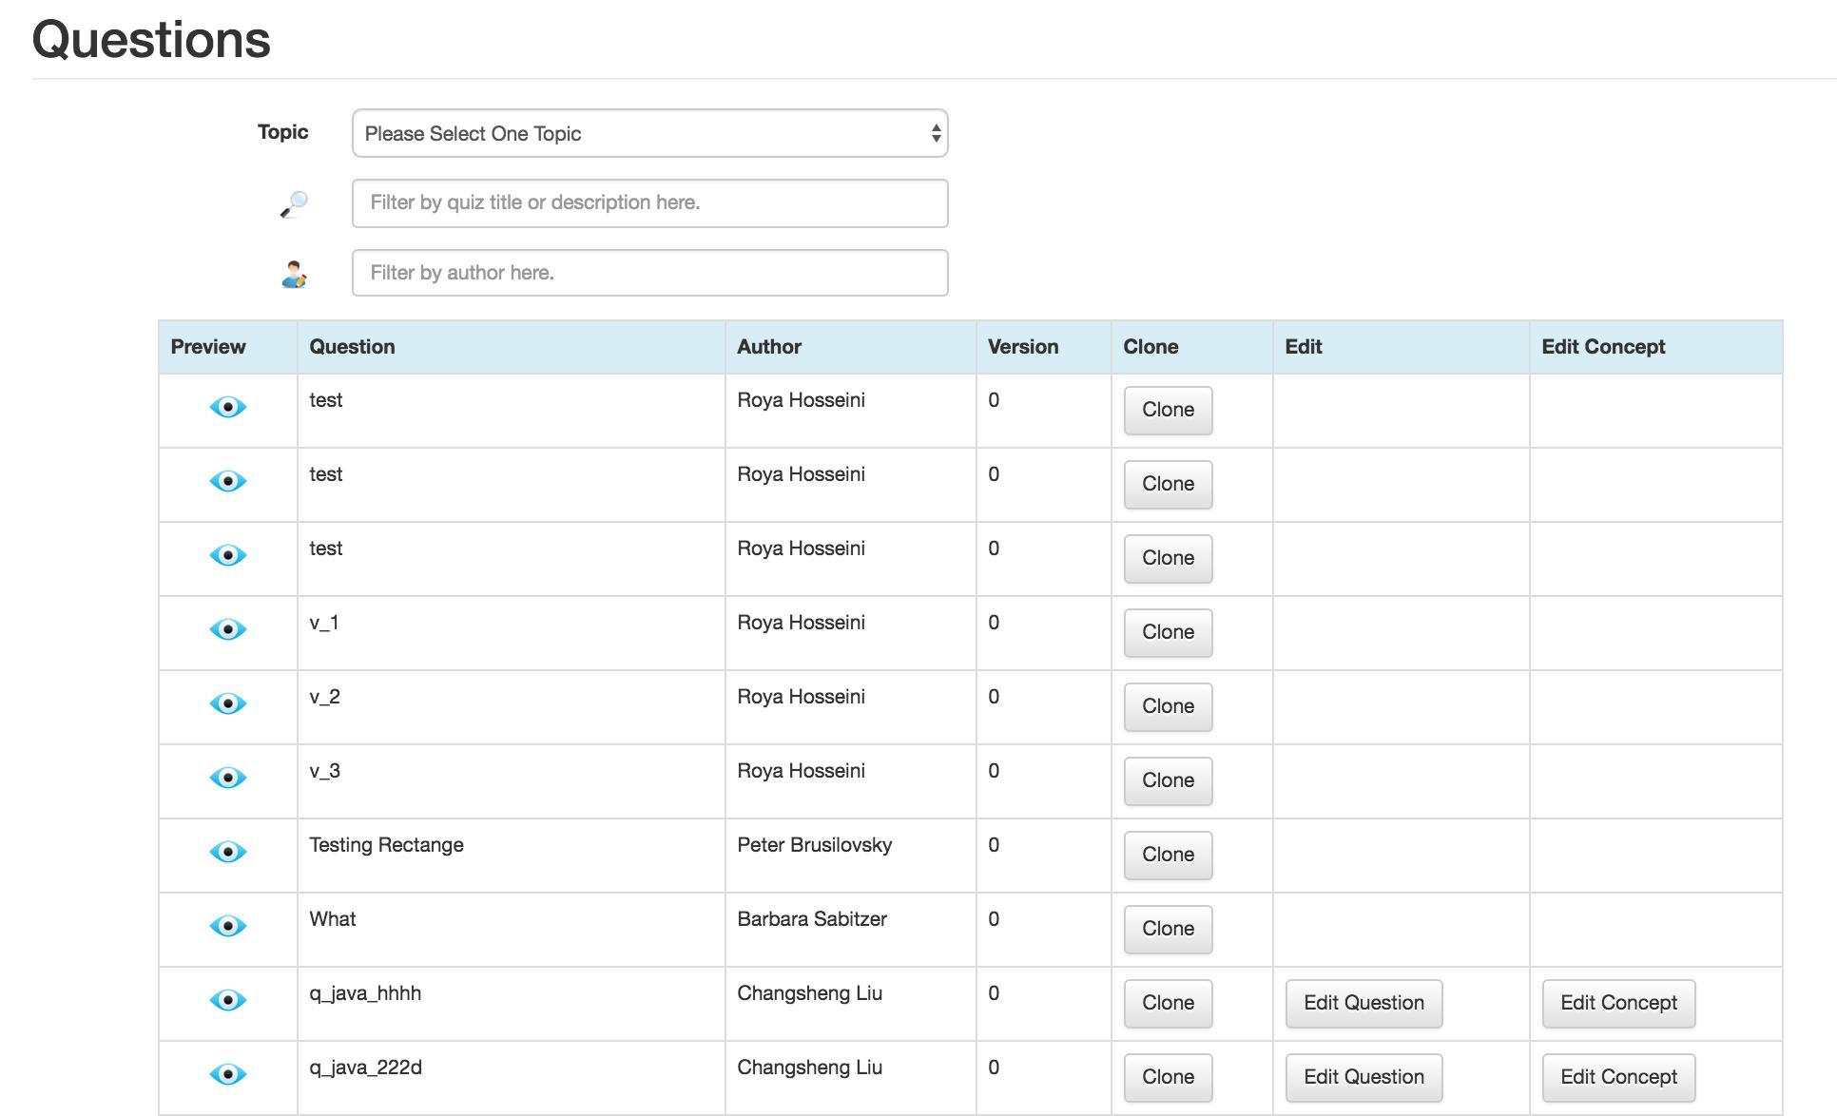

This is a snapshot of editing a question.

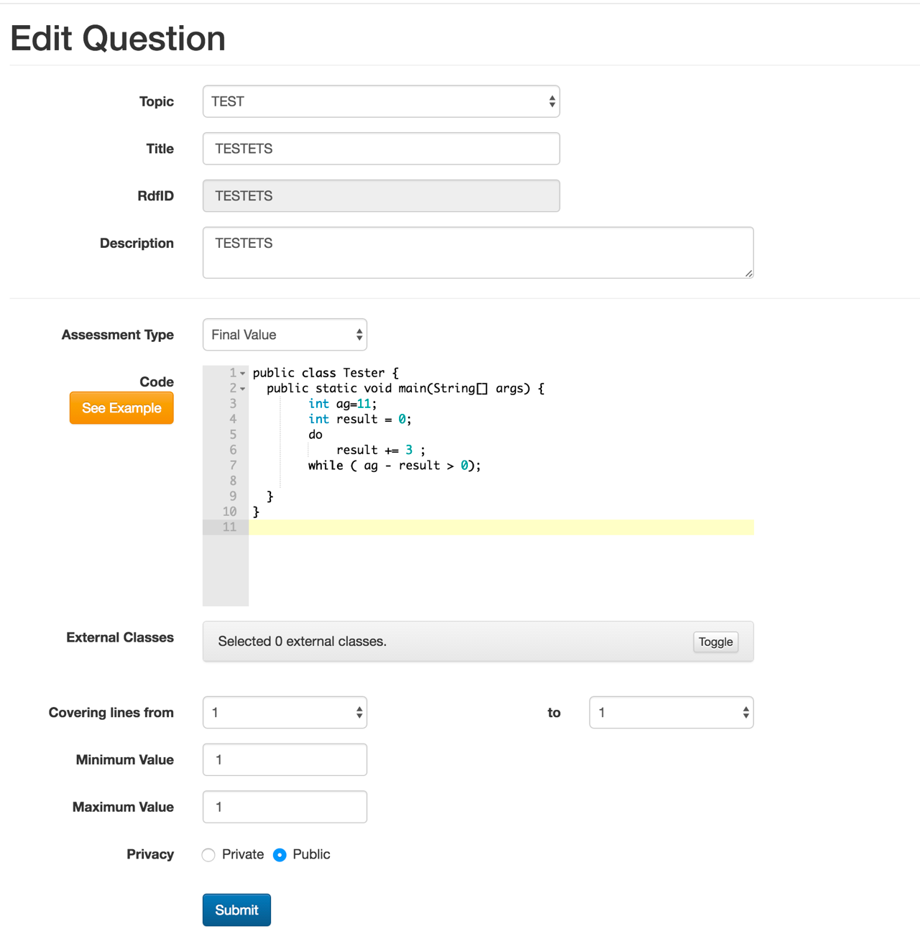

If some values like Minimum Value and Maximum Value cannot be seen, please type anything on the code panel and delete them so as to trigger onChange event

Reparse

You can edit concepts of a question. The system will generate all related concepts to a question automatically. You can delete a concept and edit the line numbers corresponding to a concept.

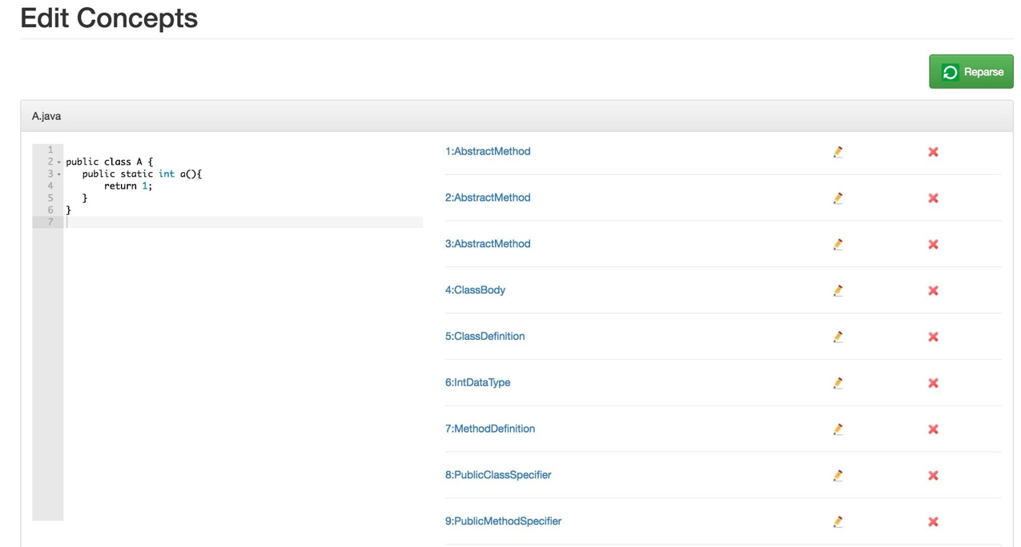

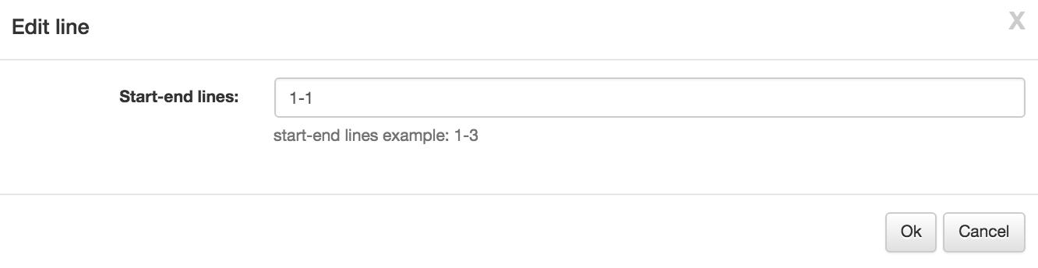

There is a set of concepts available that you can also add to your questions.

